NAME : Pushti Shah SAP ID: 60019210097
ROLL NO: B074 BRANCH: CSE-ICB

Experiment 2

Aim: Implementation of VLAN (Layer‑2 Security)

Objective:
In this lab, students will:
- Install Cisco Packet Tracer 9.0.0
- Learn how to navigate the Packet Tracer interface
- Create a simple network topology
- Configure VLANs on a switch
- Assign ports to VLANs
- Verify VLAN isolation (Layer‑2 security)
- Test connectivity using simulation tools
This document contains step‑by‑step instructions with mouse clicks, icons, colors, and UI navigation details so beginners can follow easily.

Part 1 – Download and Install Cisco Packet Tracer 9.0.0

Step 1 – Open the Download Link
1. Open Google Chrome / Edge / Firefox.
2. In the address bar (top white box), paste this link:https://archive.org/download/cisco-packet-tracer-900-win-64bit/CiscoPacketTracer_900_win_64bit.exe
3. Press Enter key.

Step 2 – Download the Installer
1. The file will start downloading automatically.
2. You will see the download progress at the bottom of the browser.
3. Wait until the file is fully downloaded.

File name should look like:

CiscoPacketTracer_900_win_64bit.exe

Step 3 – Run the Installer
1. Go to your Downloads folder.
2. Double‑click on:CiscoPacketTracer_900_win_64bit.exe
3. If Windows shows a security popup:
  - Click Yes button.

Step 4 – Installation Wizard
1. The setup window opens.
2. Click Next button (blue button).
3. Accept the license agreement:
  - Select I Agree radio button.
  - Click Next.
4. Choose install location (keep default).
5. Click Next.
6. Click Install.
7. Wait for installation to finish.
8. Click Finish.
A desktop shortcut icon will appear:
Cisco Packet Tracer icon

Part 2 – Launching Cisco Packet Tracer
1. Double‑click the Cisco Packet Tracer desktop icon.
2. If login screen appears:
  - Click Login.
  - It will redirect you to login page on browser.
Main application window will open.

Part 3 – Understanding Packet Tracer Interface

Main Sections of Screen

1. Menu Bar (Top)
- File
- Edit
- Options
- View
- Help

Used for saving, opening, preferences, etc.

2. Toolbar (Below Menu)
Icons include:

- 📁 New file
- 💾 Save
- 🔍 Zoom In / Out
- ▶️ Simulation controls

3. Workspace (Center White Area)
- This is where you build the network.
- You drag and drop devices here.

4. Device Selection Panel (Bottom Left)
Contains icons:
🖥️ End Devices
- 🔀 Switches
- 🌐 Routers
- ⚡ Connections

5. Device Models Panel (Bottom Right)
Shows specific models when you select a category.

Example:

- Switch → 2960
- PC → PC‑PT

Part 4 – Creating Network Topology

🖧 Network Design
We will create:
- 1 Switch
- 4 PCs

PC1, PC2 → VLAN 10
PC3, PC4 → VLAN 20

Step 1 – Add a Switch
1. In bottom left panel, click Switches icon (🔀).
2. In bottom right panel, click 2960 switch.
3. Click once on the white workspace to place the switch.

Step 2 – Add PCs
1. Click End Devices icon (🖥️).
2. Click PC‑PT.
3. Click on workspace four times to place 4 PCs.

Rename PCs:
1. Click PC → Config tab → Display Name
2. Rename as:
  - PC1
  - PC2
  - PC3
  - PC4

Step 3 – Connect Devices
1. Click Connections icon (⚡ yellow lightning icon).
2. Select Copper Straight‑Through cable (black line icon).

Connect:

- PC1 → Switch FastEthernet0/1
- PC2 → Switch FastEthernet0/2
- PC3 → Switch FastEthernet0/3
- PC4 → Switch FastEthernet0/4

To connect:

- Click PC → click Switch port

Green dots indicate successful connection.

Part 5 – Assign IP Addresses

For Each PC
1. Click PC.
2. Click Desktop tab.
3. Click IP Configuration.
4. Enter values:

PC1:

IP: 192.168.10.10
Subnet: 255.255.255.0

PC2:

IP: 192.168.10.11
Subnet: 255.255.255.0

PC3:

IP: 192.168.20.10
Subnet: 255.255.255.0

PC4:

IP: 192.168.20.11
Subnet: 255.255.255.0

Close window.

Part 6 – Configure VLANs on Switch

Open Switch CLI
1. Click on Switch.
2. Click CLI tab.
3. Press Enter until you see:

Switch>

Create VLANs
Type commands exactly:

enable
configure terminal
vlan 10
name SALES
exit
vlan 20
name HR
exit

Assign Ports to VLANs
interface fastEthernet0/1
switchport mode access
switchport access vlan 10
exit
interface fastEthernet0/2
switchport mode access
switchport access vlan 10
exit
interface fastEthernet0/3
switchport mode access
switchport access vlan 20
exit
interface fastEthernet0/4
switchport mode access
switchport access vlan 20
exit
exit

Verify VLAN Configuration
show vlan brief

You should see ports mapped to VLANs.

Switch#show vlan brief
VLAN Name Status Ports
---- -------------------------------- --------- -------------------------------
1 default active Fa0/5, Fa0/6, Fa0/7, Fa0/8
Fa0/9, Fa0/10, Fa0/11, Fa0/12
Fa0/13, Fa0/14, Fa0/15, Fa0/16
Fa0/17, Fa0/18, Fa0/19, Fa0/20
Fa0/21, Fa0/22, Fa0/23, Fa0/24
Gig0/1, Gig0/2
10 SALES active Fa0/1, Fa0/2
20 HR active Fa0/3, Fa0/4
1002 fddi-default active
1003 token-ring-default active
1004 fddinet-default active
1005 trnet-default active

Part 7 – Testing VLAN Security

Ping Test
1. Click PC1.
2. Desktop → Command Prompt.
3. Type:

ping 192.168.10.11
Ping should succeed.

Cross VLAN Test
From PC1:
ping 192.168.20.10
Ping should fail.
This proves VLAN isolation.

Part 8 – Simulation Mode (Optional)
1. Click Simulation button (bottom right).
2. Click Play button ▶️.
3. Watch packet flow animation.

OUTPUT:
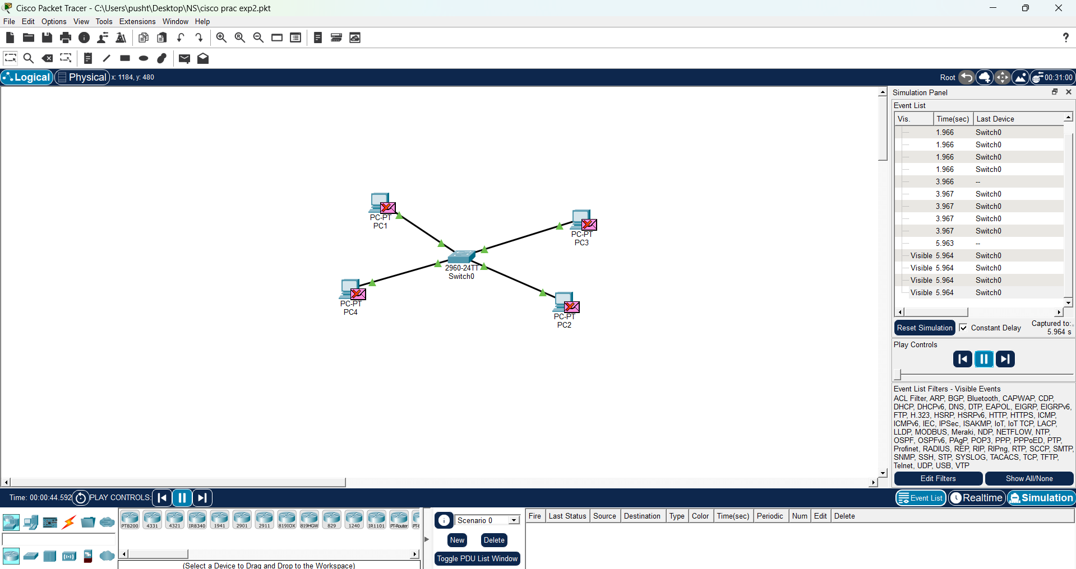

Conclusion:
In this experiment, we successfully implemented VLAN (Virtual Local Area Network) to achieve Layer-2 security using Cisco Packet Tracer. We learned how to install and navigate the tool, create a network topology, and configure VLANs on a switch.

By assigning different ports to separate VLANs (VLAN 10 and VLAN 20), we logically divided the network into isolated segments. Devices within the same VLAN were able to communicate successfully, while communication between different VLANs failed, demonstrating proper network isolation and enhanced security.

This experiment helped in understanding how VLANs improve network management, reduce broadcast domains, and provide security by restricting unauthorized access between departments. Overall, VLAN configuration is an essential concept in modern networking for building secure and efficient networks.

